System Analysis Tasks for Jim's Fresh Fruit Click & Collect eStore

# Task 1

Functional Requirements

1. User Registration and Login: The system should allow customers to create an account, log in, and manage their profile.
2. Product Catalogue: Display a list of available fresh fruits with details such as name, price, description, and availability.
3. Shopping Cart: Customers can add, remove, and update items in a virtual shopping cart before checking out.
4. Order Placement: Customers can place orders online and select a preferred date and time for collection.
5. Payment Processing: The system should securely process online payments through various payment methods (credit card, debit card, etc.).
6. Order Management: Staff can view, update, and manage customer orders, including marking orders as prepared and ready for collection.
7. Inventory Management: Real-time tracking of fruit inventory to prevent overselling and manage stock levels.
8. Customer Notifications: Automated notifications to customers about order status, including confirmation, preparation, and readiness for collection.
9. Reporting: Generate reports on sales, inventory levels, and customer order history for better business analysis.

Non-Functional Requirements

1. Performance: The system should manage up to one hundred simultaneous users without performance degradation.
2. Usability: The eStore interface should be intuitive and easy to navigate for users with varying levels of technical expertise.
3. Security: Ensure all customer data, including personal and payment information, is encrypted, and securely stored.
4. Availability: The eStore should be accessible 24/7 with a 99.9% uptime guarantee to ensure constant service availability.
5. Scalability: The system should be able to scale to accommodate increased traffic and additional products without significant changes to the architecture.
6. Compliance: The system must comply with relevant data protection regulations (e.g., GDPR, CCPA).
7. Maintainability: The codebase should be well-documented and structured to facilitate easy maintenance and updates.

# Task 2

Use Case Diagram:

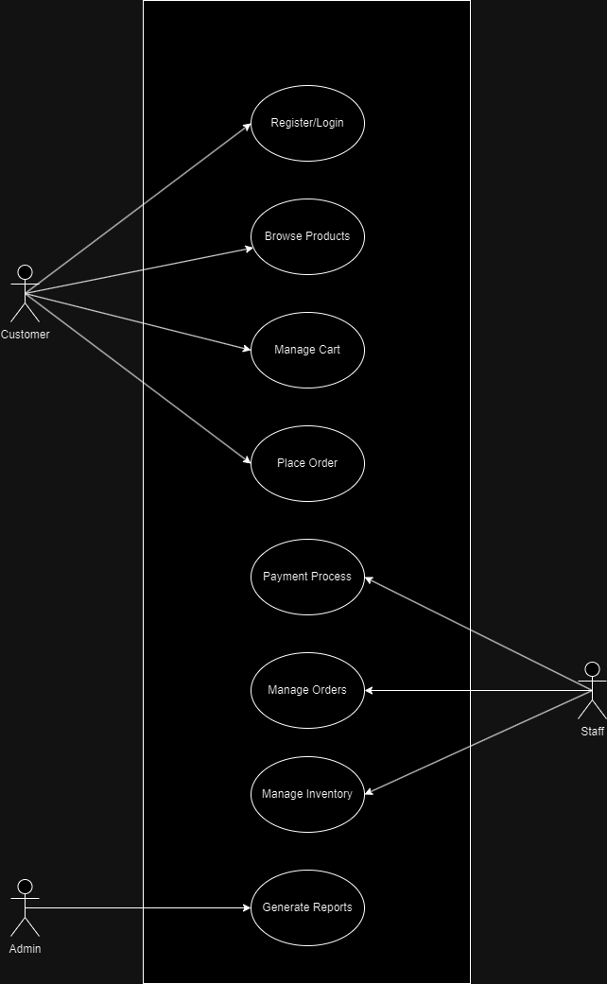

Major Use Cases:

1. Register/Login: Customers register an account or log in to access the eStore.
2. Browse Products: Customers view available fruits and their details.
3. Manage Cart: Customers add, remove, and update items in their shopping cart.
4. Place Order: Customers finalize their order, select a pickup time, and proceed to payment.
5. Process Payment: Securely manage payment information and process transactions.
6. Manage Orders: Staff view, update, and prepare orders for pickup.
7. Manage Inventory: Staff update inventory levels and product details.
8. Generate Reports: Admin generates reports on sales, inventory, and customer behaviour.

Actors:

1. Customer: A user who browses the eStore, places orders, and collects purchases.
2. Staff: Employees of Jim's Fresh Fruit who manage inventory, process orders, and handle customer service.
3. Admin: A higher-level staff member who manages the eStore, including user management, inventory updates, and generating reports.

# Task 3

Domain Class Diagram:

Classes:

1. Customer: Attributes include customerID, name, email, password, address, and phoneNumber.
2. Product: Attributes include productID, name, description, price, and stockQuantity.
3. Order: Attributes include orderID, orderDate, status, and totalAmount. Relationships with Customer and OrderItem.
4. OrderItem: Attributes include orderItemID, quantity, and subtotal. Relationships with Order and Product.
5. Payment: Attributes include paymentID, paymentMethod, paymentDate, and paymentAmount. Relationship with Order.
6. Staff: Attributes include staffID, name, role, and email.
7. Admin: Attributes include adminID, name, and email. Inherits from Staff.

Relationships:

- A Customer can place multiple Orders.

- An Order contains multiple OrderItems.

- Each OrderItem is associated with a Product.

- Staff and Admin manage Orders and Inventory.

# Task 4

Use Case 1: Place Order

1. Customer selects fruits to add to the shopping cart.
2. Customer proceeds to checkout.
3. System displays order summary.
4. Customer confirms the order and selects a pickup time.
5. System processes payment.
6. System sends order confirmation to the customer.

Use Case 2: Manage Inventory

1. Staff logs in to the system.
2. Staff views current inventory levels.
3. Staff updates stock quantities as needed.
4. System saves the updated inventory data.
5. System generates an inventory update confirmation.

